**Chatbots :**

Businesses have broadly embraced algorithms ever since Facebook opened Messenger to them in 2016. They are currently a hot topic, and companies value them greatly. But what are chatbots precisely, and why have they grown to be so crucial?You can learn the solutions to these queries as well as the significance of chatbots in this chatbot guidance.  
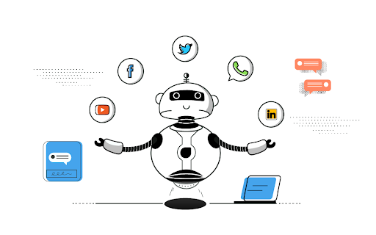

Report a content problem

Additional Resources

[#what is a chatbot ?](https://www.youtube.com/watch?v=mSY6JrJZ4aw)

What is a chatbot ?

A chatbot is a piece of software that mimics human-like text-based chat interactions with people.  
Its main duty is to assist users by responding to their inquiries. Bots can communicate with numerous people at once and answer questions quickly.  
As a result, they are now widely utilized to facilitate company and customer communication on websites and mobile messaging applications.  
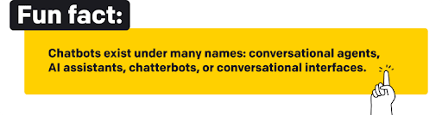

AI Chatbots :

An AI chatbot is software that can freely communicate with users. AI communication applications are much better conversationalists than their rule-based counterparts because they leverage machine learning, natural language processing (NLP), and sentiment analysis.  
Machine Learning (ML) allows bots to identify patterns in user input, make decisions, and learn from past conversations.  
Natural Language Processing (NLP) helps bots understand how humans communicate and enable them to replicate that behavior. NLP lets them understand the context of the conversation even if a person makes a spelling mistake or uses jargon.  
The sentiment analysis helps a chatbot understand users' emotions.  
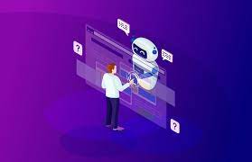

AI Chatbots :

AI communication bots need to be well-trained and equipped with predefined responses to get started. However, as they learn from past conversations, they don't need to be updated manually later.

AI bots can understand multiple languages and read the customer's mood. This enables them to personalize their communication with the user.  
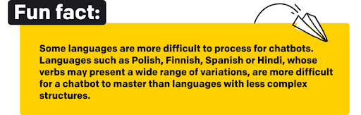

Bots vs chatbot ? :

Although the terms chatbot and bot are used interchangeably, there's a significant difference between them.  
A chatbot is a computer program designed to communicate with users. It analyzes users' questions to provide matching answers. Businesses use chatbots to support customers and help them accomplish simple tasks without the help of a human agent.  
A bot is an algorithm that interacts with web content. Bots help businesses and users perform helpful, mundane, or complex tasks faster online. Below are some different types of bots.:

* Search engine bots and crawlers are used by Google and Yahoo to index web content and scale web cataloging. This helps users easily find information related to their search intent.
* Feed bots look for new information on the web to add to news sites.
* Copyright bots look for content that violates copyright laws. They help companies and authors check whether their proprietary content has been used without approval.

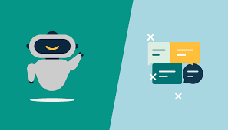

Why do businesses need chatbots?

Technological progress has radically changed the way people communicate. Face-to-face interactions have been largely replaced by online messaging. This has forced businesses to adapt to a new type of communication. To achieve success, brands need to provide a seamless buyer's journey. They must respond to customer questions around the clock and across multiple channels.  
But living up to the rising expectations of “always-connected” customers is not the easiest and cheapest task. The more your business grows, the more it costs to deliver 24/7 customer service. This is where chatbots come in handy. They allow brands to scale up their support services at a low cost.  
More and more often, companies are deciding to introduce bot applications into their marketing strategies because they allow for delivering personalized and consistent brand experiences. Long term, that translates into better brand perception and more sales.

Marketing :

Brands use conversational agents to diversify their customer-engagement strategy. With them, businesses engage website visitors proactively and, eventually, sell more products.  
It's for good reason that more and more companies are hiring conversation designers who know how to write engaging chatbot scenarios. Businesses have already realized that a well-written chatbot can work as a successful lead generation tool. It can collect newsletter subscribers, sales contacts, beta testers, or even job candidates by helping companies reach a larger audience with their message.  
One of the brands that took their online service to the next level using a bot is Sephora. The company uses it to educate customers about its cosmetics.  
Their AI assistant offers makeup tutorials and skincare tips and helps customers purchase products online. The company even enables its customers to try new makeup using AR technology implemented in their chatbot. By doing this, Sephora has delivered its personalized customer experience in-store and online.  
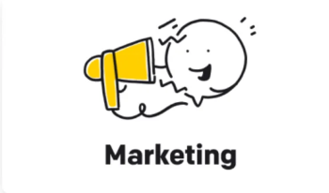

Customer support :

The use of chatbots in customer service has revolutionized the industry by allowing customers to have their problems addressed immediately and through their preferred channels. Companies like Mastercard and Next Door Burger Bar are using chatbots to provide 24/7 support and help customers with simple tasks like checking transactions and ordering food online. Not only do chatbots allow companies to scale their services at a low cost, but they also meet changing customer expectations. Additionally, chatbots can function as the first line of customer support by taking over repetitive cases from live agents and routing customers to agents when necessary, which boosts productivity for support teams.

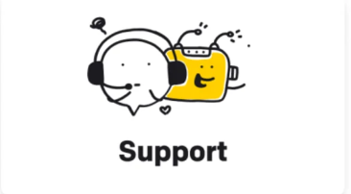

Sales :

The sales funnel is a critical process that every customer goes through before purchasing a product, and chatbots have emerged as a game-changer in this process. By guiding customers through the various stages of the funnel, including awareness, interest, decision, and action, conversational interfaces have been shown to increase conversion rates by up to 30%. National Geographic, for instance, used a Messenger bot to attract users to its new ebook, Almanac, and boosted sales by offering a 10% discount. Starbucks also uses AI to help customers order their favorite coffee drink on the go, providing a better brand experience. Chatbots also help sales teams by eliminating unqualified leads and connecting sales reps with qualified ones, enabling them to build stronger relationships with prospects. Moreover, chatbots act as a repository of customer knowledge, providing valuable insights into customer preferences and enabling companies to tailor their messages and offers better.  
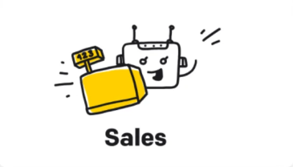

the powerful new AI chatbot from OpenAI :

We can observe various use cases of chatbots with the widely popular chatbot, Chat GPT-3, which has taken the scene by storm. So, what exactly is Chat GPT-3, how was it built, and what are its limitations and drawbacks?  


What Is ChatGPT?

ChatGPT is an artificial intelligence tool that allows a user to generate original text. You can ask it questions, give it creative prompts, and use it to generate a whole bunch of different stuff—from poems, to songs, to essays, to short stories.  
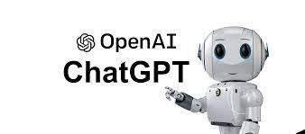

When Did ChatGPT Come Out, and Where Does It Come From?

ChatGPT was created by OpenAI and launched in November of 2022 . Partially founded by Elon Musk, OpenAI is an organization that is dedicated to the research and development of artificial intelligence. OpenAI has a number of other controversial investors, such as rightwing billionaire Peter Thiel, who offered a substantial amount of financial assistance to the org when it was first setting up shop. OpenAI is run by CEO Sam Altman, who is also a founder of the organization.  
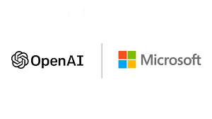

How Does ChatGPT Work?

ChatGPT is powered by a sophisticated algorithm called a large language model. Such algorithms are fed with massive amounts of textual data, which then allow them to respond to prompts in a realistic, human-like fashion, a computational system known as natural language processing.  
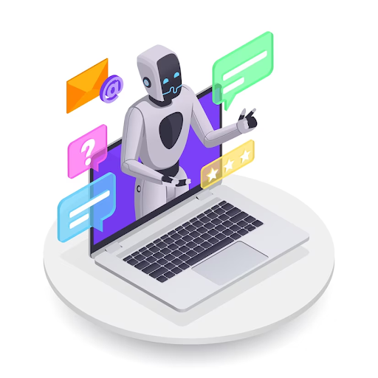

Report a content problem

Additional Resources

[#Everything to know about Open AI's viral chat bot ChatGPT](https://www.businessinsider.com/everything-you-need-to-know-about-chat-gpt-2023-1)

Python-powered AI :

ChatGPT, like many other advanced deep learning models, was built using Python, which is a popular programming language in the data science and machine learning community. Python offers a large number of open-source libraries and frameworks that simplify the development and deployment of complex machine learning models.  
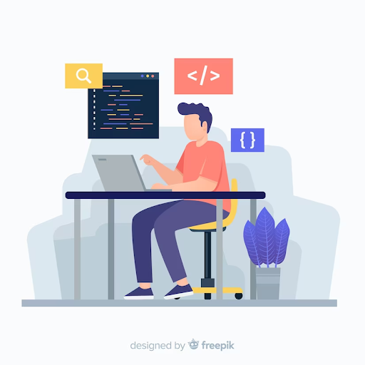

Report a content problem

Additional Resources

[#Everything to know about Open AI's viral chat bot ChatGPT](https://www.businessinsider.com/everything-you-need-to-know-about-chat-gpt-2023-1)

PyTorch Innovate :

PyTorch, a popular deep learning framework built on top of Python, was used to develop ChatGPT. PyTorch offers an easy-to-use interface for building and training deep learning models, as well as a dynamic computational graph that makes it easy to experiment with different model architectures and configurations.  
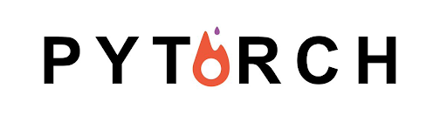

Report a content problem

Additional Resources

[#Everything to know about Open AI's viral chat bot ChatGPT](https://www.businessinsider.com/everything-you-need-to-know-about-chat-gpt-2023-1)

DeepText Hub :

The developers of ChatGPT also used the Hugging Face Transformers library, which is built on top of PyTorch and provides a high-level API for working with pre-trained language models, including GPT-2 and GPT-3. This library simplifies the process of loading pre-trained models, fine-tuning them for specific tasks, and generating text from them.

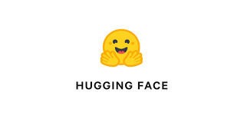

Report a content problem

Additional Resources

[#Everything to know about Open AI's viral chat bot ChatGPT](https://www.businessinsider.com/everything-you-need-to-know-about-chat-gpt-2023-1)

Summary :

ChatGPT, a highly advanced conversational AI model, was developed using the Python programming language, PyTorch deep learning framework, and Hugging Face Transformers library. Python's vast array of open-source libraries and frameworks has made it a popular choice for building complex machine learning models. PyTorch offers an intuitive interface for developing and training deep learning models, while Hugging Face Transformers simplifies the process of loading pre-trained models, fine-tuning them, and generating text. With these powerful tools at its disposal, ChatGPT has revolutionized the field of conversational AI and continues to evolve and improve over time.  
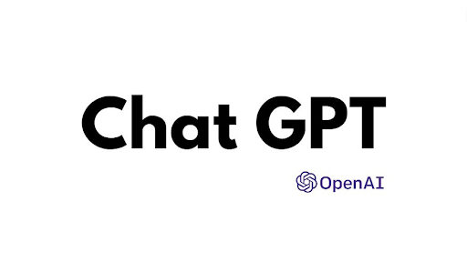

Report a content problem

Additional Resources

[#Everything to know about Open AI's viral chat bot ChatGPT](https://www.businessinsider.com/everything-you-need-to-know-about-chat-gpt-2023-1)

Who Is ChatGPT for?

Pretty much anybody can use ChatGPT! As long as you set up an account with OpenAI, you should be good to go.

Are ChatGPT’s Answers Always Correct?

No. In fact, the platform is known for making a lot of things up, and its answers can often be wrong. If you’re planning on relying on ChatGPT to write an essay or an article, you’re going to want to fact check everything it says.  
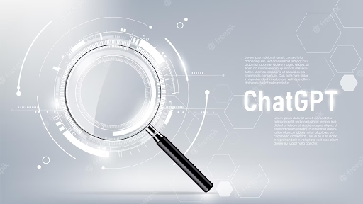

Report a content problem

Additional Resources

[#CNNs for Classification](https://www.analyticsvidhya.com/blog/2020/02/learn-image-classification-cnn-convolutional-neural-networks-3-datasets/)

Are There Problems With ChatGPT?

As much as ChatGPT has excited users, a number of concerns exist about how the platform and others of its kind will impact existing industries as well as educational institutions like colleges and high schools. Some of the concerns include that ChatGPT could...

* Kill the college essay and lead to other academic dysfunction
* Make human writers obsolete
* Generate factually inaccurate news articles (already happened)
* Cause a new disinformation typhoon with such easily-generated text
* Democratize cybercrime and helping to fuel easy malware creation
* Get loads of people fired
* ...and more!

Report a content problem

Additional Resources

[#CNNs for Classification](https://www.analyticsvidhya.com/blog/2020/02/learn-image-classification-cnn-convolutional-neural-networks-3-datasets/)

Who is ChatGPT’s Competition?

Even though ChatGPT may have been the first AI chatbot to capture Americans’ hearts, it certainly won’t be the last. In fact, since OpenAI launched its little app last November, other large tech platforms have rushed to release their own versions of the same technology. So far, we’ve heard about...

* Google has announced a ChatGPT competitor, an expensive lookalike dubbed “Bard.” Bard had sort of a rough start, when it was launched in early February, spouting some incorrect information during its demo.
* Meta has also announced its own super smarty pants chatbot: the LLaMA. Not much is known about this furry guy, but Mark seems to think you’re going to have a fun time with him soon enough.

Microsoft/Bing’s ChatBOT integration, otherwise known as “Prometheus,” continues to be the most finished product out of all of these, currently enjoying its limited beta. But who knows how long that will last?

Report a content problem

Additional Resources

[#CNNs for Classification](https://www.analyticsvidhya.com/blog/2020/02/learn-image-classification-cnn-convolutional-neural-networks-3-datasets/)

ChatGPT :

ChatGPT is an advanced deep learning model that uses natural language processing to generate human-like responses to text-based input. It was built using the Python programming language and the PyTorch deep learning framework, as well as the Hugging Face Transformers library for working with pre-trained language models. ChatGPT has gained popularity due to its ability to generate contextually relevant and coherent responses to a wide range of conversational prompts. However, it also has limitations and potential ethical concerns related to its ability to mimic human communication and potentially spread misinformation.

Report a content problem

Additional Resources

[#CNN for MNIST on kaggle](https://www.kaggle.com/elcaiseri/mnist-simple-cnn-keras-accuracy-0-99-top-1)

Our Personalized Chatbot :

Having gained knowledge about ChatGPT, it is now time to delve deeper and explore the process of constructing our very own chatbot. By incorporating the latest advancements in technology, we can create a chatbot that is equipped with cutting-edge features and capabilities. With the right tools and resources, building a chatbot can be an exciting and rewarding experience that opens up a world of possibilities for engaging with users in a more personalized and effective manner.  
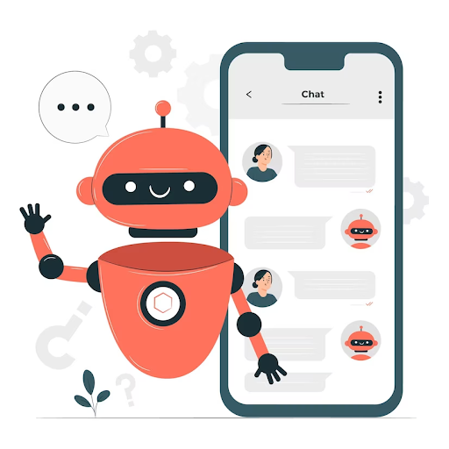

Report a content problem

Additional Resources

[#CNN for MNIST on kaggle](https://www.kaggle.com/elcaiseri/mnist-simple-cnn-keras-accuracy-0-99-top-1)

Start creating our own chatbot :

This is an example of how to create a simple chatbot using natural language processing (NLP) techniques in Python.  
Now, let's go through this code step by step :

Importing necessary libraries:

To install the necessary libraries, you can use the following command in your command prompt or terminal:

pip install nltk streamlit

Once you have installed the libraries, you can import them in your Python script using the following code:

import nltk

nltk.download('punkt')

nltk.download('averaged_perceptron_tagger')

from nltk.tokenize import word_tokenize, sent_tokenize

from nltk.corpus import stopwords

from nltk.stem import WordNetLemmatizer

import string

import streamlit as st

The ‘nltk’ library is used for natural language processing tasks such as tokenization, lemmatization, and stopword removal. The ‘string’ library is used for string operations. The ‘streamlit’ library is used to create the web-based chatbot interface.

The ‘nltk.download()’ function is used to download additional resources needed for the nltk library. In this case, we are downloading the punkt and averaged_perceptron_tagger resources. These resources are needed for tokenization and part-of-speech tagging tasks.

Once you have imported the necessary libraries, you can use their functions and classes to perform various NLP tasks and create your chatbot.

Report a content problem

Additional Resources

[#CNN for MNIST on kaggle](https://www.kaggle.com/elcaiseri/mnist-simple-cnn-keras-accuracy-0-99-top-1)

Loading and Preprocessing Data:

The first step in building a chatbot is to load and preprocess the data that the chatbot will use to generate responses. In this example, we will load a text file and preprocess each sentence in the file to create a corpus that the chatbot can use to find the most relevant response.  
Here's the code to load and preprocess the data:

*# Load the text file and preprocess the data*

with open('D:/ww2.txt', 'r', encoding='utf-8') as f:

data = f.read().replace('\n', ' ')

*# Tokenize the text into sentences*

sentences = sent_tokenize(data)

*# Define a function to preprocess each sentence*

def preprocess(sentence):

*# Tokenize the sentence into words*

words = word_tokenize(sentence)

*# Remove stopwords and punctuation*

words = [word.lower() for word in words if word.lower() not in stopwords.words('english') and word not in string.punctuation]

*# Lemmatize the words*

lemmatizer = WordNetLemmatizer()

words = [lemmatizer.lemmatize(word) for word in words]

return words

*# Preprocess each sentence in the text*

corpus = [preprocess(sentence) for sentence in sentences]

Report a content problem

Additional Resources

[#CNN for MNIST on kaggle](https://www.kaggle.com/elcaiseri/mnist-simple-cnn-keras-accuracy-0-99-top-1)

Loading and Preprocessing Data:

First, we open the text file using the open() function and read the contents of the file using the read() method. We replace any newline characters (\n) with a space character to ensure that each sentence is on a separate line.  
Next, we use the sent_tokenize() function from the nltk.tokenize module to tokenize the text into individual sentences.  
We then define a function called preprocess() that takes a sentence as input and performs the following preprocessing steps:

1. Tokenize the sentence into individual words using the word_tokenize() function from the nltk.tokenize module.
2. Remove stopwords and punctuation from the list of words using a list comprehension. We use the stopwords.words('english') function from the nltk.corpus module to get a list of English stopwords, and the string.punctuation constant to get a string of all punctuation characters.
3. Lemmatize the words using the WordNetLemmatizer() class from the nltk.stem module. Lemmatization is the process of reducing a word to its base form (e.g., "running" to "run").

Report a content problem

Additional Resources

[#CNN for MNIST on kaggle](https://www.kaggle.com/elcaiseri/mnist-simple-cnn-keras-accuracy-0-99-top-1)

Defining the Similarity Function:

he get_most_relevant_sentence() function is responsible for finding the most relevant sentence in the corpus given a user query. Here's how it works:

*# Define a function to find the most relevant sentence given a query*

def get_most_relevant_sentence(query):

*# Preprocess the query*

query = preprocess(query)

*# Compute the similarity between the query and each sentence in the text*

max_similarity = 0

most_relevant_sentence = ""

for sentence in corpus:

similarity = len(set(query).intersection(sentence)) / float(len(set(query).union(sentence)))

if similarity > max_similarity:

max_similarity = similarity

most_relevant_sentence = " ".join(sentence)

return most_relevant_sentence

Report a content problem

Additional Resources

[#CNN for MNIST on kaggle](https://www.kaggle.com/elcaiseri/mnist-simple-cnn-keras-accuracy-0-99-top-1)

Defining the Similarity Function:

1. Preprocess the user query using the preprocess() function defined earlier.
2. Iterate over each sentence in the corpus.
3. Compute the similarity between the preprocessed query and the current sentence using the Jaccard similarity coefficient. The Jaccard similarity coefficient is a measure of similarity between two sets and is defined as the size of the intersection divided by the size of the union of the sets. In this case, we treat the preprocessed query and each sentence in the corpus as sets of words and compute their Jaccard similarity coefficient.
4. Update the most relevant sentence if the current sentence has a higher similarity score.
5. Return the most relevant sentence.

Report a content problem

Additional Resources

[#CNN for MNIST on kaggle](https://www.kaggle.com/elcaiseri/mnist-simple-cnn-keras-accuracy-0-99-top-1)

The chatbot Function:

The chatbot() function is the main function that takes a user's question as input, processes it using the get_most_relevant_sentence() function, and returns the most relevant sentence as the chatbot's response.  
Here's how it works:

def chatbot(question):

*# Find the most relevant sentence*

most_relevant_sentence = get_most_relevant_sentence(question)

*# Return the answer*

return most_relevant_sentence

Report a content problem

Additional Resources

[#CNN for MNIST on kaggle](https://www.kaggle.com/elcaiseri/mnist-simple-cnn-keras-accuracy-0-99-top-1)

The chatbot Function:

1. The chatbot() function takes a user's question as input.
2. It calls the get_most_relevant_sentence() function to get the most relevant sentence from the corpus that matches the user's query.
3. It returns the most relevant sentence as the chatbot's response.

Report a content problem

Additional Resources

[#CNN for MNIST on kaggle](https://www.kaggle.com/elcaiseri/mnist-simple-cnn-keras-accuracy-0-99-top-1)

Creating a Streamlit App :

The main() function creates a Streamlit app that provides a user interface for the chatbot. Here's how it works:

*# Create a Streamlit app*

def main():

st.title("Chatbot")

st.write("Hello! I'm a chatbot. Ask me anything about the topic in the text file.")

*# Get the user's question*

question = st.text_input("You:")

*# Create a button to submit the question*

if st.button("Submit"):

*# Call the chatbot function with the question and display the response*

response = chatbot(question)

st.write("Chatbot: " + response)

if __name__ == "__main__":

main()

Report a content problem

Additional Resources

[#CNN for MNIST on kaggle](https://www.kaggle.com/elcaiseri/mnist-simple-cnn-keras-accuracy-0-99-top-1)

Conclusion :

In summary, the code provided defines a simple chatbot using Python's Natural Language Toolkit (NLTK) and Streamlit. The chatbot is designed to provide answers to questions related to a specific topic, as described in a text file.  
The code consists of several functions:

* preprocess(): This function preprocesses a sentence by tokenizing it into words, removing stopwords and punctuation, and lemmatizing the words.
* get_most_relevant_sentence(): This function finds the most relevant sentence in the text file given a user query. It does this by computing the similarity between the query and each sentence in the text file and returning the sentence with the highest similarity score.
* chatbot(): This function uses the get_most_relevant_sentence() function to get the most relevant sentence for a given user question and returns it as the chatbot's response.
* main(): This function creates a Streamlit app that provides a user interface for the chatbot. It prompts the user to enter a question and displays the chatbot's response on the screen.

Overall, the chatbot is a simple example of how NLTK and Streamlit can be used to create a conversational interface for answering questions related to a specific topic. With further development and refinement, the chatbot could be made more robust and capable of answering a wider range of questions.  
I hope this explanation helps you understand this code and gives you an idea of how to build your own chatbot using natural language processing techniques.

Report a content problem

Additional Resources

[#CNN for MNIST on kaggle](https://www.kaggle.com/elcaiseri/mnist-simple-cnn-keras-accuracy-0-99-top-1)